Advanced Data Analysis and Visualization in Logistic

Objective
The objective of this task is to perform advanced data analysis and visualization on a hypothetical logistics dataset using Python. The study focuses on understanding logistics performance metrics such as shipment distance, shipment volume, delivery time, and transportation cost. Exploratory Data Analysis (EDA) and data visualization techniques are used to identify trends, relationships, cost drivers, and operational insights that can support data-driven decision-making in logistics management.
Dataset Description
A hypothetical logistics dataset was created for analysis purposes. The dataset contains information about shipments and logistics operations.
Dataset Variables:
- Shipment_ID – Unique shipment identifier
- Distance_km – Distance traveled by shipment (in kilometers)
- Shipment_Volume_tons – Volume of goods transported (in tons)
- Delivery_Time_hours – Time taken for delivery (in hours)
- Transportation_Cost – Total transportation cost of shipment
The dataset was analyzed using Python and Pandas to understand logistics performance and identify operational trends.
Methodology
The analysis was performed using Python programming language. Pandas was used for data handling and Exploratory Data Analysis (EDA), while Matplotlib was used for creating visualizations.
The methodology consisted of:
- Creating a hypothetical logistics dataset.
- Loading the dataset into a Pandas DataFrame.
- Performing descriptive statistical analysis.
- Calculating averages, minimum values, maximum values, and standard deviations.
- Creating visualizations to study relationships among logistics variables.
- Interpreting the results and deriving business insights.
Python Code Used :
import pandas as pd
import numpy as np

np.random.seed(42)

df = pd.DataFrame({
"Shipment_ID":[f"S{i:03d}" for i in range(1,31)],
"Distance_km":np.random.randint(100,1000,30),
"Shipment_Volume_tons":np.random.randint(5,30,30),
"Delivery_Time_hours":np.random.randint(4,30,30),
"Transportation_Cost":np.random.randint(5000,40000,30)
})
Exploratory Data Analysis (EDA)
Descriptive statistics were calculated to understand shipment distance, shipment volume, delivery time, and transportation cost. The analysis provided insights into average performance and variability across logistics operations.
Visualizations
- Distance vs Transportation Cost (Scatter Plot) 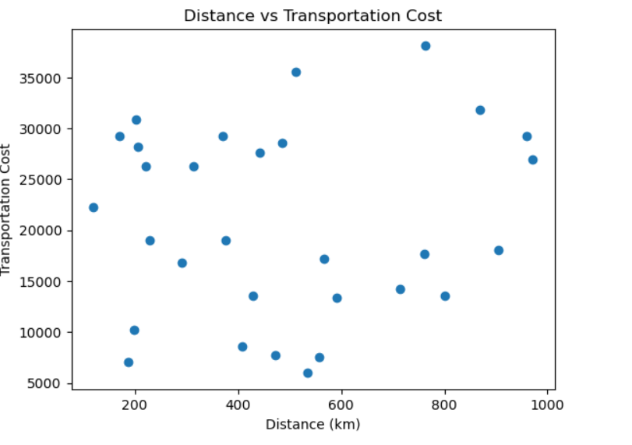
2. Delivery Time by Shipment (Bar Chart) 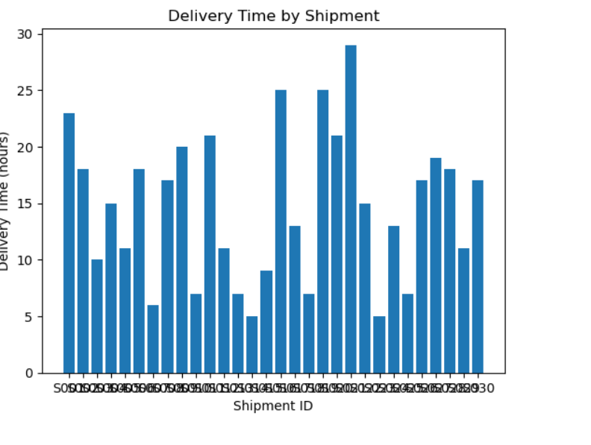

3. Distribution of Delivery Time (Histogram) 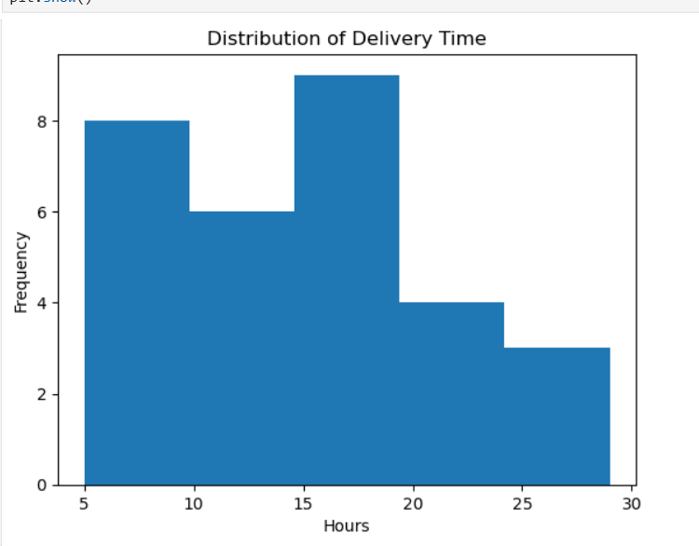

Analytical Insights
• Transportation cost is influenced by shipment distance.
• Longer routes require more delivery time.
• Shipment volume affects resource requirements.
• Visual analytics helps identify operational patterns.
Recommendations
• Optimize routes to reduce transportation costs.
• Monitor delivery times regularly.
• Improve resource allocation based on shipment volume.
• Use data analytics for logistics planning.
Conclusion
This project demonstrated the use of Python for advanced data analysis and visualization in logistics. The findings highlighted relationships among shipment distance, delivery time, shipment volume, and transportation cost. Data-driven decision-making can improve operational efficiency and reduce logistics costs.

